
Year 11 Earth and Environmental Science

TASK 6- Test

End of Semester Topic test

Name:  Date: | Teacher: | Score:  / 26

1. Which of the following has the is the least hardness according to Moh’s scale?
a) Diamond
b) Quartz
c) Talc
d) Fluorite

2. Which plate boundary movement is expected when a continental and an oceanic plate converge?
a) Oceanic plate subducts under the continental plate boundary
b) Continental plate subducts under the oceanic plate
c) Both push against each other forming mountains
d) Both converge to form a trench

3. Which is a geological feature created by a divergent boundary
a) Deep ocean Trench
b) Volcano
c) Mid ocean ridge
d) Subduction zone

4. On which tectonic plate boundary does New Zealand sit?
a) Australia plate/ Scotia plate
b) Australia plate/ New Zealand plate
c) New Zealand plate/ Pacific plate
d) Australia plate/ Pacific plate

5. What type of fault is the Darling fault and what type of movement occurred
a) Normal fault- Darling scarp moved down
b) Reverse fault- Darling Scarp moved up
c) Normal fault- Darling Scarp moved up
d) Reverse fault- Darling Scarp moved down

6. The San Andreas fault is an example of which type of boundary?
a) Convergent
b) Divergent
c) Consistent
d) Transform

7. Which type of seismic waves are known as body waves
a) L and R
b) S and P
c) S and R
d) L and S

8. Which of the following is an example of an igneous rock?
a) Obsidian
b) Marble
c) Gneiss
d) Limestone

9. Which of the following is an example of a metamorphic rock?
a) Gabbro
b) Siltstone
c) Granite
d) Marble

10. Which of the following is not an agent of erosion?
a) Temperature
b) Wind
c) Water
d) Ice

11.In the image below what type of weathering has occurred?
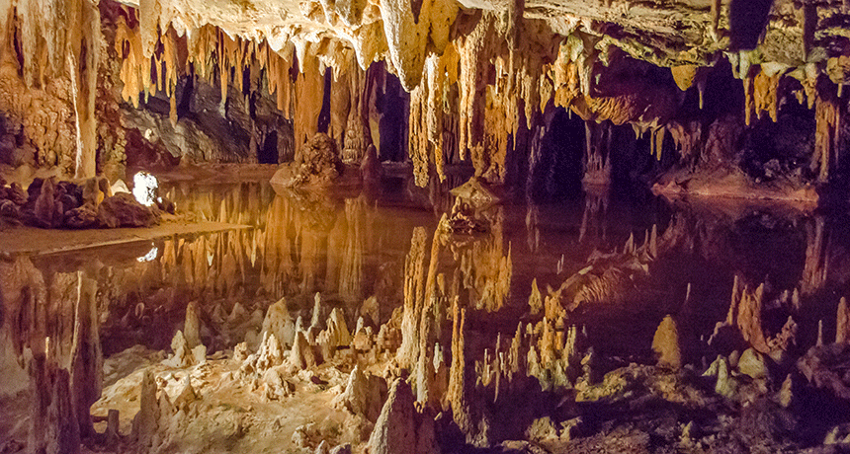
a) Oxidation
b) Solution and carbonation
c) Frost wedging
d) Biological weathering

12. Which of the following in NOT an example of biological weathering?
a) Plants growing through rock cracks
b) Humans mining
c) Animals burrowing within a rock
d) Rocks breaking apart due to temperature change

13. Which method of soil conservation describes leaving 30% of crop on the surface during peak soil erosion periods?
a) Conservation tillage
b) Cover crops
c) Alley cropping
d) Strip cropping

14. Which is the correct definition for porosity?
a) Ability of soils to transmit water
b) How easily water flows through the soil profile
c) Size of the gaps between soil particles
d) how easily soils are eroded

15. Which of the following soils would have the smallest porosity?
a) Silt
b) Clay
c) Clay loam
d) Sand

SHORT ANSWER SECTION
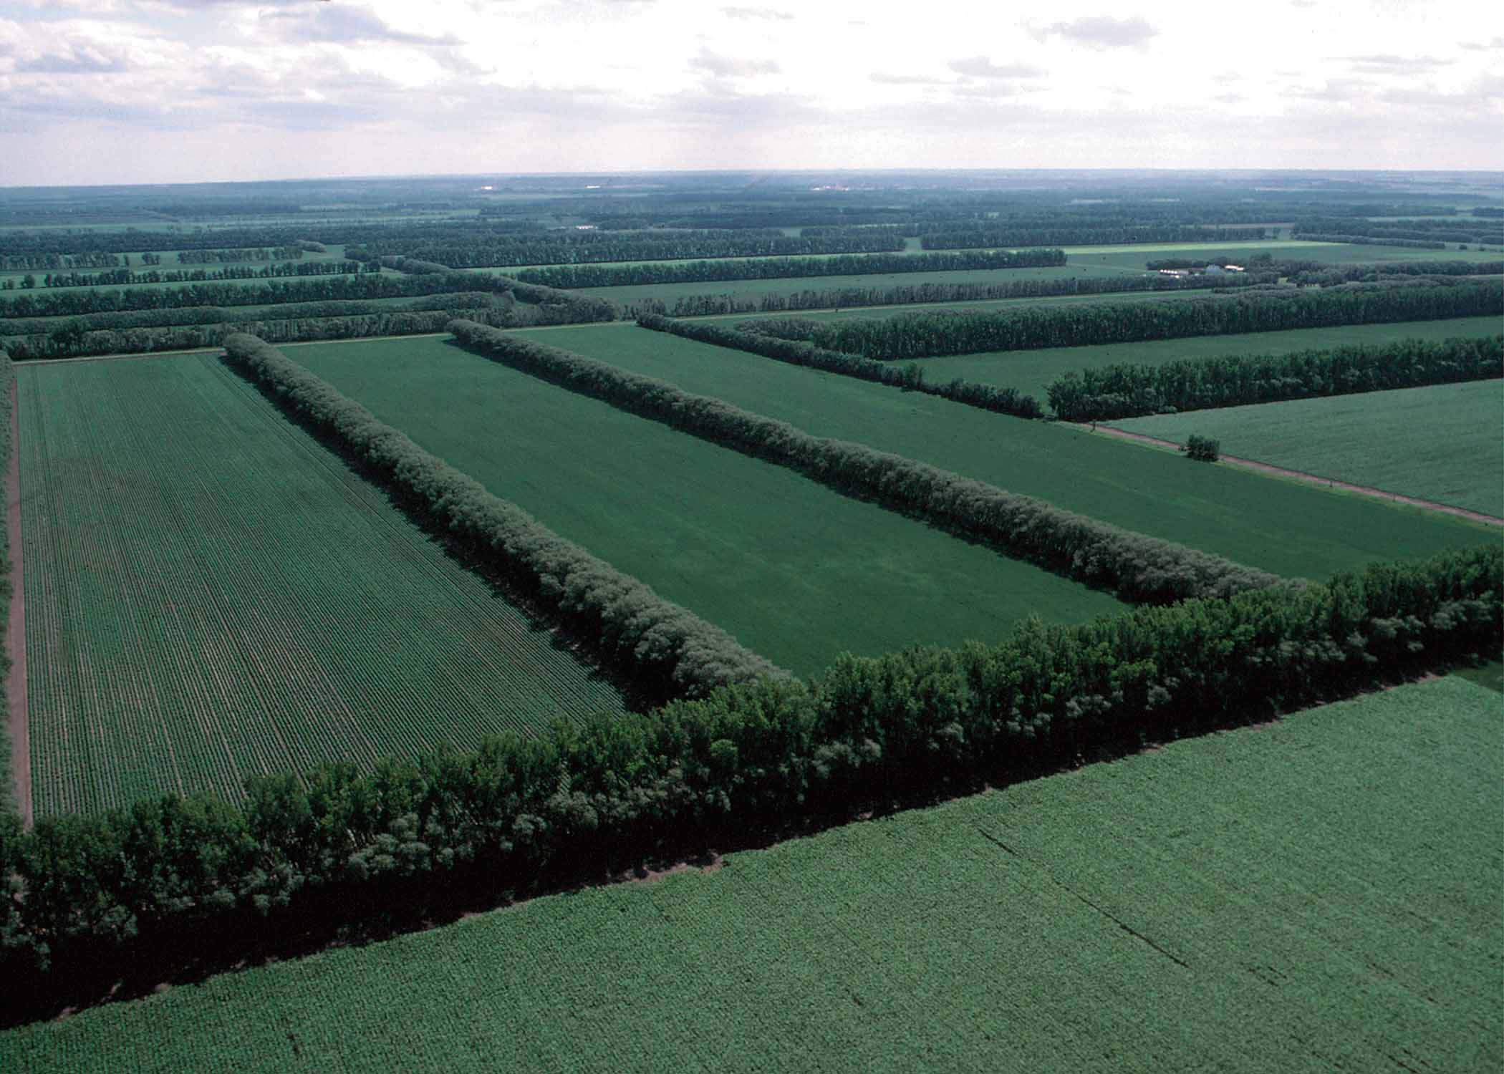
16. Below is an image of a soil conservation method. Please name the method and describe why this is used to preserve soils. (3 marks) _______________________________________________________
_______________________________________________________
_______________________________________________________
_______________________________________________________
_______________________________________________________

17. Give an example of each type of weathering (3 marks)
Physical | Chemical | Physical- Biological Weathering

18. Explain why Australia is relatively geologically stable (2 marks)
_______________________________________________________________________________________________
_______________________________________________________________________________________________
19. Describe the formation of intrusive igneous rocks referring to crystal size and time for cooling (4 marks)
_______________________________________________________________________________________________
_______________________________________________________________________________________________
_______________________________________________________________________________________________
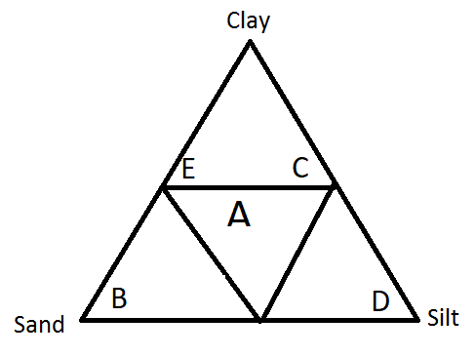
_______________________________________________________________________________________________
20. Label the following soils in the soil texture triangle below (5 marks)
A _______________________________
B _______________________________
C _______________________________
D _______________________________
E _______________________________
21. Complete the following table in relation to the development of knowledge around plate tectonics (6 marks)
Theory | Scientist | Evidences
Continental Drift Theory | Alfred Wegener | 1.  2.  3.  4.
Sea Floor Spreading | Harry Hammond Hess | 1.  2.

22. List the landforms created along a convergent boundary between a continental and an oceanic boundary (4 marks)
_______________________________________________________________________________________________
_______________________________________________________________________________________________
_______________________________________________________________________________________________
_______________________________________________________________________________________________
23. Which is older, mid ocean ridges or abyssal plains? Explain why. (3 marks)
_______________________________________________________________________________________________
_______________________________________________________________________________________________
_______________________________________________________________________________________________
24. Complete the following table (6 marks)
Image | Rock properties | Type of rock | Reasons for
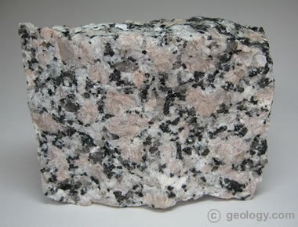 | - Large crystals inside a fine grained mass  - Crystals made up of quartz, feldspar and mica
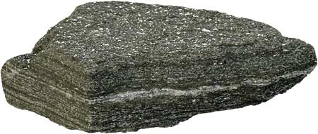 | - Rock has layers  - Hard  - Shiny in coloured bands
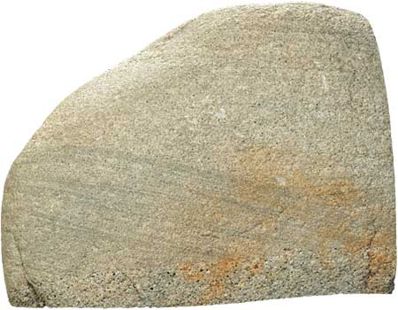 | - Light in colour  - Contains deformed fossils  - Clasts of minerals

25. Students were investigating the water holding capacity of different soil types. They collected the data in the table below. As they boiled the water they measured the weight of the soil at 2 minutes intervals
Time | Soil A (g) | Soil B (g) | Soil C (g)
0 | 80.3 | 79.2 | 80.5
2 | 65.2 | 78.7 | 70.1
4 | 50.2 | 76.2 | 62.1
6 | 45.2 | 74.5 | 53.1
8 | 41.2 | 70 | 48.1
10 | 38.2 | 64.2 | 47.2
12 | 37.1 | 58.2 | 45.9
14 | 36.8 | 51.2 | 45.1
16 | 36.2 | 42.1 | 44.7
18 | 36.1 | 36.2 | 44.3
20 | 36 | 35.2 | 44.2

a) Graph the following data on the grid attached (5 marks)
b) List the amount of water lost for each soil type (3 marks)
________________________________________________________________________________________________________
________________________________________________________________________________________________________
________________________________________________________________________________________________________
c) Based on the graph can you label which soil type is which (3 marks)
________________________________________________________________________________________________________
________________________________________________________________________________________________________
________________________________________________________________________________________________________

